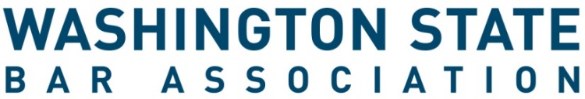

Board of Governors Congressional District - Application Form

All Application materials must be received by 5 p.m. PST on Tuesday, April 7, 2026.
Late materials will not be accepted.

INSTRUCTIONS
- Review all information regarding board service, the application and the election processes online here.
- Complete this required application form. If you are nominating someone else, ask them to sign it below.
- Email this signed form and materials to barleaders@wsba.org. Applications must be received by 5 p.m. PST on Tuesday, April 7, 2026. Late materials will not be accepted.
_____________________________________________________________________________________

Applicant Information
Name | Click or tap here to enter text.
WSBA Bar # | Click or tap here to enter text.
Email Address | Click or tap here to enter text.
Phone Number | Click or tap here to enter text.
Congressional District Position: | ☐ District 2  ☐ District 3  ☐ District 6

Candidate for position on the Washington State Bar Association Board of Governors

I, the undersigned Active member of the Washington State Bar Association, am running for the office of Governor from the above indicated district.

Name of Candidate (please print) WSBA Bar #

Signature of Nominator (if applicable) WSBA Bar #

Signature of Candidate

The WSBA values diversity and inclusion, and encourages Black, Indigenous and people of color, women, people from the LBGTQ communities, people with disabilities, and members of other groups who have been systemically oppressed to apply for our committees, boards, and panels. This process is administered by the Office of the Executive Director. Submit the application form and all materials to WSBA no later than 5 p.m. PST on April 7, 2026. Filing may be accomplished by emailing the form to barleaders@wsba.org. For questions, please email barleaders@wsba.org.

