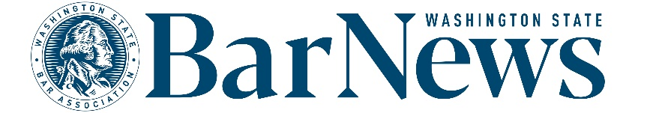

EAC MEETING MINUTES
Wednesday, April 15, 2-3 p.m.

Roll call

EAC Members: Benjamin Gould, Roxanne Degens, Rose Valera, Allison Foreman, Thom Williams, James Wade

WSBA Staff: Kirsten Lacko, Colin Rigley, Connor Luk, Jessica Randklev, Katrina Mulligan

Editor’s Report

- Volunteer application opens May 1.
  - Volunteer fair on 4/17 for anyone interested in other volunteer opportunities.
  - Members cycling off the committee in September: Allison Foreman, Thom Williams, Leron Vandsburger
  - Members who can reapply for a second term: David Ziff, Suellen Siqueira-Fisher, Ben Gould
  - Members who are in the middle of their current term: James Wade, Rose Valera, Priyanka Menon, Brenna Pink Pampena, Roxanne Degens

- AI policy discussion follow-up.
  - The Bar News team will draft a policy to govern author use of generative AI and bring back to the EAC for further discussion.
  - General consensus: Use of generative AI is OK for research, editing, and other minor tasks, but not for generating magazine content.
  - We will draft an attestation form where authors will be asked to answer a few questions about AI use. When AI is used in the allowable ways listed above, a disclaimer will be put at the top of the article.

Issue review: The full group reviewed the February issue.

Story ideas: Committee members shared updates on articles currently in development.

Questions/Good of the order/Announcements

Upcoming meeting dates: May 20, June 17, July 15, Aug. 19, Sept. 16

End of meeting 2:31 p.m.

