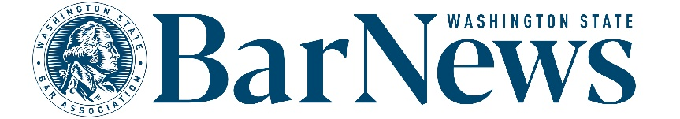

**EAC MEETING MINUTES**

Wednesday, July 16, 2-3 p.m.

**Roll call**

**EAC Members:** Benjamin Gould, Thom Williams, David J.S. Ziff, Robbie Philbrick, Susan Moss, Priscilla Moreno, Allison Foreman, Suellen Siqueira-Fisher

**WSBA Staff:** Kirsten Lacko, Jessica Randklev, Connor Luk, Katrina Mulligan

**Editor’s Report**

* [**Letters policy**](https://www.wsba.org/docs/default-source/news-events/publications/nwlawyer/letters-to-the-editor-policy_final_v2.docx?sfvrsn=8a4408f1_0)**.** 
  + - Discussion of minor potential future changes to the letters policy. If changes are proposed, the EAC will be consulted for feedback and a vote, hopefully at the August meeting.
* **Website report.**
  + Top online articles from June 1-30*:*
    1. [June Discipline Notices](https://wabarnews.org/2025/06/12/june-2025-discipline-other-regulatory-notices/) (983 views) (June 2025)
    2. [In Remembrance](https://wabarnews.org/in-remembrance/) (809 views)(June 2025)
    3. [Legislative Recap](https://wabarnews.org/2025/06/12/a-recap-of-the-2025-washington-legislative-session/) (477 views)(June 2025)
    4. [Navigating Tribal Law Research](https://wabarnews.org/2025/06/12/navigating-tribal-law-research-a-short-guide-for-washington-attorneys/) (440 views)(June 2025)
    5. [Restoring Faith in the Law](https://wabarnews.org/2025/06/12/restoring-faith-in-the-law/) (392 views)(June 2025)

**Issue review: Robbie Philbrick** reviewed the **June 2025** issue.

**Story ideas:** Committee members shared updates on articles currently in development.

**Questions/Good of the order/Announcements**

**End of meeting 2:40 p.m.**

**Upcoming meeting dates:** August 20, September 17