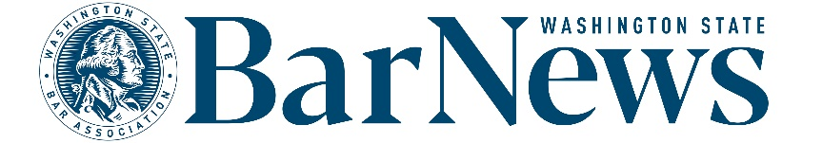

EAC MEETING MINUTES
Wednesday, March 18, 2026 2-3 p.m.
Roll call

EAC Members: Roxanne Degens, Rose Valera, Priyanka Menon, Benjamin Gould (chair), Thom Williams, David J.S. Ziff, James Wade, Allison Foreman.
WSBA Staff: Colin Rigley, Kirsten Lacko, Katrina Mulligan, Colin Rigley, Jessica Randklev.

BOG Liaison: Matthew Dresden

Editor’s Report

- AI policy discussion. The Bar News team plans to draft a policy to govern author use of generative AI in the magazine. First, the team wanted to gather input from the EAC. Members discussed the following questions:
  - What are your thoughts on the use of generative AI to research, write, and/or edit content? Do you personally use it? In what ways?
  - How do you feel about reading content that is disclosed to have been written/researched/or edited using generative AI?
- Some members expressed extreme hesitancy in using generative AI for anything, including work product. Other members said they use AI for research and certain tasks.
The AI policy discussion took up the entire meeting time. No story ideas discussion or issue review took place.
Questions/Good of the order/Announcements

Upcoming meeting dates: April 15, May 20, June 17, July 15, Aug. 19, Sept. 16

