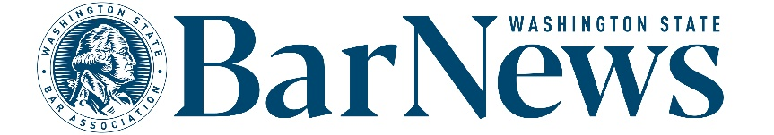

**EAC MEETING MINUTES**

Wednesday, May 21, 2-3 p.m.

**Roll call**

**WSBA Staff:** Kirsten Lacko, Jessica Randklev, Connor Luk, Colin Rigley **EAC Members:** Susan Moss, Benjamin Gould, Nicholas Marler, Thom Williams, James Wade, David Ziff

**BOG Liaison:** Kristina Larry

**Editor’s Report**

* **WSBA Community pilot project coming to an end.** Discussion of how to move on from software, what to use in the future.
* [**Letters policy**](https://www.wsba.org/docs/default-source/news-events/publications/nwlawyer/letters-to-the-editor-policy_final_v2.docx?sfvrsn=8a4408f1_0)**.** 
  + - Discussion of potential future changes to the policy.
* **WSBA articles in progress.** Committee members provided feedback to WSBA staff on several potential story ideas.
* **Website report.**
  + Top online articles from April 1-30:
    1. [April/May Discipline Notices](https://wabarnews.org/2025/04/14/apr-may-2025-discipline-other-regulatory-notices/) (1,222 views)
    2. [In Remembrance](https://wabarnews.org/in-remembrance/) (790 views)
    3. [Interview with Justice Sal Mungia](https://wabarnews.org/2025/04/14/committed-to-community/) (477 views)
    4. [Wellness After Grief and Loss](https://wabarnews.org/2025/04/14/wellness-after-grief-and-loss/) (425 views)
    5. [President’s Corner-The Rule of Law](https://wabarnews.org/2025/04/14/presidents-corner-the-rule-of-law-the-historic-role-of-lawyers-as-defenders-and-a-new-opportunity-as-rule-of-law-ambassadors/) (289 views)
  + **Positive outlier:** “Amendments to CR 26 and 30 Will Change Discovery and Deposition Practice” (Nov 2024)(total views to date 3,812)

**Issue review: Nick Marler** reviewed the **April/May** issue.

**Questions/Good of the order/Announcements**

**Upcoming meeting dates:** June 18, July 16, August 20, September 17