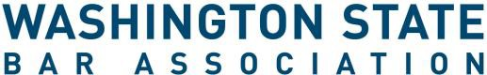

ATTACHMENT “A” – DEFINITION OF RURAL

For purposes of the WSBA Rural Practice Summer Internship Grant rural areas are defined as: “Employers not located in Thurston, Clark, Pierce, King, Snohomish, Spokane, and Whatcom counties, WITH the provision that if the employer is in a town of 5,000 or less within said counties it will qualify.

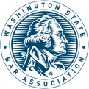
1325 4th Avenue | Suite 600 | Seattle, WA 98101-2539
800-945-WSBA | 206-443-WSBA | questions@wsba.org | www.wsba.org

