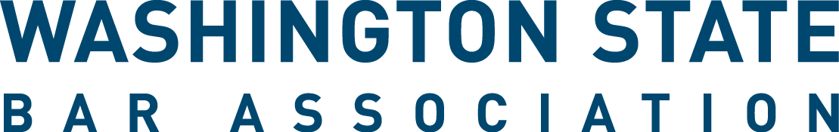

WSBA Young Lawyer Liaison to Sections Application
The WSBA Young Lawyer Liaison to Sections Program creates an opportunity for a WSBA Section to strengthen the connection with the new and young lawyer community by electing a new and young lawyer to serve as a Liaison to the section. In collaboration with the section, Liaisons volunteer by bringing their perspective and connections to building educational programming, events, and other section activities tailored to new and young lawyers.

In order to become a Liaison, applicants must meet the “Young Lawyer” qualification in the WSBA Bylaws, meaning that they are an active member of the WSBA who have been admitted to practice for less than five years in any jurisdiction, or who is age 36 or younger, whichever is later. Young Lawyers who want to apply to more than one section liaison position must fill out an application for each section.

The position is a two-year term beginning Oct. 1, 2021 or thereafter, unless otherwise indicated. Applicants who are chosen to serve as Liaisons must attend a virtual Liaison orientation with WSBA staff and section leadership.

- First Name: ________________________________

- Last Name: ________________________________

- Bar Number: ________________________________
- Email Address: ________________________________

- City: ________________________________
(Where you practice if employed. If unemployed, indicate your city of residence.)

- Section Selection: Below are the sections that have an opening for a liaison. You must submit a separate application form for each section in which you apply. (*Indicates 1-year interim term to end September 30, 2022.)

☐Civil Rights Law
☐Senior Lawyers

- Resume and Other Materials. To apply, you are required to submit your resume. It is also recommended that you provide a statement of interest. Email this application, your resume, and any additional materials to newmembers@wsba.org.

- How did you hear about this opportunity (select one)?
☐Website, WSBA.org
☐WSBA Email
☐New Lawyers List Serve
☐WSBA Sections
☐Washington Young Lawyers Committee
☐Colleague/Friend
☐Other:

Thank you for your interest in WSBA’s Young Lawyer Liaison to Sections Program! We will notify all applicants of the final once the sections make their decision. If you have questions, please email curtissm@wsba.org.

