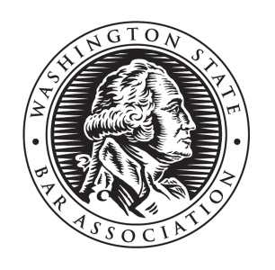

2019 Deadline:
Saturday, May 4
Washington Young Lawyers Committee
Public Service and Leadership Award

This year the Washington Young Lawyers Committee will honor five new or young lawyers with the Public Service and Leadership Award. The Washington State Bar Association considers an active member a young or new lawyer if at least one of two criteria is met: 1) the member has been admitted to practice for fewer than five years (in any state), or 2) the member is under 36 years of age.
Attorneys must be nominated by another individual. To complete a nomination, submit the application below and a current resume of the nominee to newmembers@wsba.org. A subcommittee of the WYLC will consider the nominee’s leadership in their community and involvement in public service activities as described in RPC 6.1. Long-term service or an extraordinary contribution to the community will be considered, including:
- leadership and service in the local community or within a bar association;
- WSBA, ABA, or local bar association activities;
- Volunteering with pro bono or public service programs; or
- Writing a blog post for NWSidebar and/or writing an article for NWLawyer.
Recipients may only receive the award once during the WSBA fiscal year (October 1 –September 30). A confirmation e-mail will be sent directly from WSBA to the award recipient for their selection and their name may be posted on the WSBA website, publications and/or social media. Each recipient will be eligible to attend one free (or no-cost) WSBA-CLE program of up to six credits total to be used within one year of receiving the award.
Date:
Nominee Name:
Firm/Employer:
Mailing Address:
City: | State: |  | Zip Code:
Phone: | Fax: |  | E-Mail:
WSBA No. |  | Year Admitted to Practice In Washington:
Nominator’s Name: |  | Relationship to Nominee:

Please complete the questions found on page 2
Describe the nominee’s leadership in his or her local community:

How has the nominee promoted and/or contributed to the legal profession and community?

Describe a situation in which the nominee has “gone above and beyond”?

Additional information:

Submit application and resume to newmembers@wsba.org

