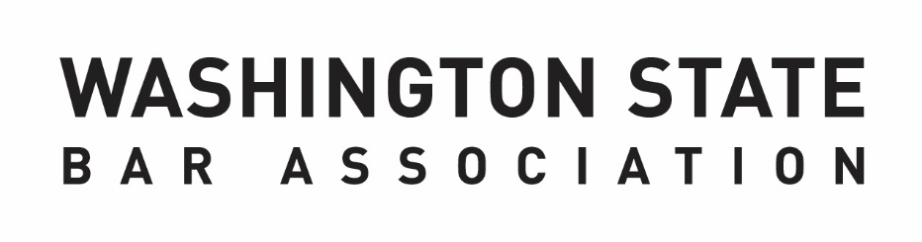

**WSBA ENTITY ANNUAL REPORT DRAFT TEMPLATE  
FY 2024: October 1, 2023 – September 30, 2024**

*The mission of the Washington State Bar Association is to serve the public and the members of the Bar, to ensure integrity of the legal profession, and to champion justice.*

**Instructions:** In accordance with the WSBA Bylaws,Committees, Other Bar Entities (excluding Regulatory Boards[1]), Councils, and Sections must submit an annual report to the Executive Director. The information below should reflect the activities and outcomes from the fiscal year October 1, 2023 – September 30, 2024. Information in the annual report will be provided to the Executive Director and Board of Governors, and may be published for other purposes, such as *Bar News*, volunteer recruitment messaging, and other WSBA activity-based reporting.

It is recommended that completion of the annual report be a collaborative effort with members of your entity, the BOG liaison, and staff liaison.

**Submission Deadline is Friday, October 11**: please submit by emailing [barleaders@wsba.org](mailto:barleaders@wsba.org) or requesting that your staff liaison submit the report internally.

|  |  |  |
| --- | --- | --- |
| **Name of Entity:** | | Click or tap here to enter text. |
| **Chair or Co-Chairs:** | | Click or tap here to enter text. |
| **Staff Liaison:** *(include name, job title, and department if known)* | | Click or tap here to enter text. |
| **Board of Governors Liaison:** | | Click or tap here to enter text. |
| **Purpose of Entity:**  *May be stated in Bylaws, Charter, Court Rule, etc.* | | |
| Click or tap here to enter text. | | |
| **Strategy to Fulfill Purpose:** | | |
| Click or tap here to enter text. | | |
| **How does the entity’s purpose help further the mission of the WSBA“to serve the public and the members of the Bar, to ensure integrity of the legal profession, and to champion justice”?** | | |
| Click or tap here to enter text. | | |
| **2023-2024 Entity Accomplishments:** | | |
| Click or tap here to enter text. | | |
| Click or tap here to enter text. | | |
| Click or tap here to enter text. | | |
| Click or tap here to enter text. | | |
| **Next Fiscal Year: 2024-2025 Top SMART Goals & Priorities:**  *SMART Goals can be an effective framework for the creation of goal; they detail the work you and your team hope to accomplish and help to foster and communicate clear expectations.*  *SMART Goals are: Specific, Measurable, Relevant and Time-Bound*  *Use the WSBA SMART Goals Worksheet to detail the groups 2024-2025 goals. After using the worksheet to describe your goals, summarize the top three SMART Goals in 2-3 sentences below.* | | |
| **1** | Click or tap here to enter text. | |
| **2** | Click or tap here to enter text. | |
| **3** | Click or tap here to enter text. | |
| **Looking Ahead:** *Please share any long-term goals and/or priorities your entity seeks to address, beyond the next fiscal year.* | | |
| **1** | Click or tap here to enter text. | |
| **2** | Click or tap here to enter text. | |
| **3** | Click or tap here to enter text. | |
| **Please describe how this entity is addressing diversity, equity, and inclusion:**  *How have you elicited input from a variety of perspectives in decision-making? What techniques do you use to promote a culture of inclusion within the board or committee? How do you seek to elicit inclusive decision-making amongst your group? What more would you like to see done in this area to better support the needs of your entity?* | | |
| Click or tap here to enter text. | | |
| **Please share feedback regarding the support and engagement provided by WSBA.** *For example:*   * *Quality of WSBA staff support/services, including technology solutions* * *Involvement with Board of Governors, including assigned BOG liaison* * *Ideas you have on ways WSBA can continue to strengthen/support your entity.* | | |
| Click or tap here to enter text. | | |
| **Entity Detail & Demographics Report:**  ***To Be Completed by WSBA Volunteer Engagement Advisor*** | | |
| **Size of Entity:** *(Include voting and non-voting members)* | | Click or tap here to enter text. |
| **Number of Vacancies for FY25:**  *The number of positions with terms beginning October 1, 2024 (FY25)* | | Click or tap here to enter text. |
| **Number of Applicants for FY25:** *Applications were submitted in the Spring-Summer of 2024 for terms beginning October 1, 2024 (FY25)* | | Click or tap here to enter text. |
| **Budgeted Direct Expenses:**  *As of September 30, 2024.* | | Click or tap here to enter text. |
| **Total FTE Support:** | | Click or tap here to enter text. |
| **Indirect Expenses:**  *As of September 30, 2024.* | | Click or tap here to enter text. |
| **FY24 Demographics:**  The WSBA promotes diversity, equality, and cultural competence in the courts, legal profession, and the bar, and is committed to ensuring that its committees, boards, and panels reflect the diversity of its membership.  Aside from the factors marked (*), demographic information was provided voluntarily and individuals had the option to not respond to any or all of the factors below.   |  |  |  | | --- | --- | --- | | **Disability** | No | % | |  | Chose Not to Respond | % | | **District\*** | 0 | % | |  | 1 | % | |  | 2 | % | |  | 3 | % | |  | 4 | % | |  | 5 | % | |  | 6 | % | |  | 7N | % | |  | 7S | % | |  | 8 | % | |  | 9 | % | |  | 10 | % | | **Ethnicity** | White or European Descent | % | |  | Middle Eastern Descent | % | |  | Multi Racial or Bi Racial | % | |  | Chose Not to Respond | % | | **Gender** | Female | % | |  | Male | % | |  | Chose Not to Respond | % | | **Sexual Orientation** | Gay, Lesbian, Bisexual, Pansexual, or Queer | % | |  | Heterosexual | % | |  | No | % | |  | Chose Not to Respond | % |   The Yes/No response for the Sexual Orientation category is data from a previous demographic question ‘Do you open identify as a sexual minority to include the following: gay, lesbian, bisexual, transgender?’ This question was on the volunteer application when some of the current members submitted their application and therefore, is still included. | | |

1. Supreme Court Boards (Access to Justice Board, Disciplinary Board, LLLT Board, Limited Practice Board, MCLE Board and Practice of Law Board) provide annual reports to WSBA to support is responsibility under [GR 12.3](https://www.courts.wa.gov/court_rules/?fa=court_rules.display&ruleid=GAGR12.3), to provide oversight and monitor compliance with applicable rules and orders. Boards have the option to use the WSBA template or to share their annual reports to the Washington Supreme Court.