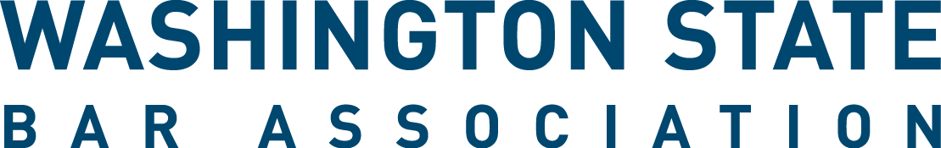

WSBA Young Lawyer Liaison to Sections - Interim Appointment Application for Vacant Positions
The WSBA Young Lawyer Liaison (Liaison to Sections Program creates an opportunity for a WSBA Section and new or young lawyers to focus on strengthening the connection between a specific section and the new and young lawyer community. In collaboration with the section, Liaisons volunteer by bringing their perspective and connections to building educational programming, events, and other section activities tailored to new and young lawyer members.

Applicants must meet the “Young Lawyer” qualification in the WSBA Bylaws. Young lawyers who want to apply to more than one section liaison position must fill out an application and statement of interest for each section. Positions will begin upon appointment and may serve up to a two-year term. WSBA Staff will coordinate a one-hour onboarding orientation with selected applicants before or near the official start of the Liaison’s term.

- First name: ________________________________

- Last Name: ________________________________

- Bar Number: ________________________________
- Email Address: ________________________________

- City: ________________________________
(Where you practice if employed. If unemployed, indicate your city of residence.)

- Section Selection: Below are the sections that have an opening for a liaison. You must submit a separate application form for each section in which you apply.

☐Elder Law
☐Juvenile Law
☐Legal Assistance to Military Personnel
☐Senior Lawyers
☐World Peace Through Law

- Resume and Other Materials. Please submit a resume. You may also submit additional files e.g. a statement of interest. Email this application, your resume, and any additional materials to newmembers@wsba.org.

- How did you hear about this opportunity (select one)?
☐Website, WSBA.org
☐WSBA Email
☐New Lawyers List Serve
☐WSBA Sections
☐Washington Young Lawyers Committee
☐Colleague/Friend
☐Other:

Thank you for your interest in WSBA’s Young Lawyer Liaison to Sections Program! We will notify all applicants of the final selection within a month of applying. If you have questions, please email newmembers@wsba.org.

