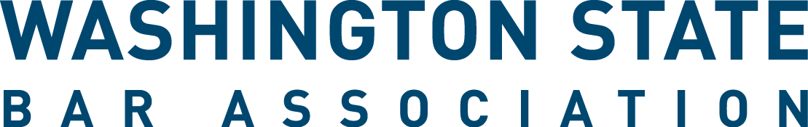

WSBA Young Lawyer Liaison to Sections Application
The WSBA Young Lawyer Liaison (Liaison to Sections Program creates an opportunity for a WSBA Section and new or young lawyers to focus on strengthening the connection between a specific section and the new and young lawyer community. In collaboration with the section, Liaisons volunteer by bringing their perspective and connections to building educational programming, events, and other section activities tailored to new and young lawyer members.

Applicants must meet the “Young Lawyer” qualification in the WSBA Bylaws. Young lawyers who want to apply to more than one section liaison position must fill out an application and statement of interest for each section. Positions begin Oct. 1, 2018 and serve a two-year term, unless otherwise indicated. Selected applicants must attend a Liaison orientation on September 17, 2018.

- First name: ________________________________

- Last Name: ________________________________

- Bar Number: ________________________________
- Email Address: ________________________________

- City: ________________________________
(Where you practice if employed. If unemployed, indicate your city of residence.)

- Section Selection: Below are the sections that have an opening for a liaison. You must submit a separate application form for each section in which you apply. (*indicates 1-year interim term)
☐Administrative Law
☐Antitrust, Consumer Protection and Unfair Business Practices*
☐Corporate Counsel
☐Creditor Debtor Rights
☐Criminal Law
☐Environmental and Land Use Law
☐Health Law
☐Intellectual Property
☐International Practice
☐Labor and Employment Law*
☐Legal Assistance to Military Personnel*
☐Lesbian Gay Bisexual Transgender Law
☐Litigation
☐Low Bono
☐Real Property, Probate and Trust
☐Senior Lawyers*
☐Solo and Small Practice
☐World Peace Through Law*

- Resume and Other Materials. Please submit a resume. You may also submit additional files e.g. a statement of interest. Email this application, your resume, and any additional materials to newmembers@wsba.org.

- How did you hear about this opportunity (select one)?
☐Website, WSBA.org
☐WSBA Email
☐New Lawyers List Serve
☐WSBA Sections
☐Washington Young Lawyers Committee
☐Colleague/Friend
☐Other:

Thank you for your interest in WSBA’s Young Lawyer Liaison to Sections Program! We will notify all applicants of the final selections in mid-late August 2018. If you have questions, please email newmembers@wsba.org.

